
NETWORK INTRUSION DETECTION SYSTEM USING
PACKET ANALYSIS AND TRAFFIC MONITORING
A CAPSTONE PROJECT REPORT
Submitted in partial fulfilment of the requirements for the Course of
CSA0716 - COMPUTER NETWORKS
to the award of the degree of
BACHELOR OF ENGINEERING
IN
ELECTRONICS AND COMMUNICATION ENGINEERING
Submitted by
P. HEMANTH REDDY (192312173)
U. PAVANESH REDDY (192372103)
M. M. ANIL (192312225)
M. RAHUL REDDY (192311334)
Under the Supervision of
Dr. P. ABERNA
SIMATS ENGINEERING
Saveetha Institute of Medical and Technical Sciences
Chennai - 602105
SEPTEMBER 2026

SIMATS ENGINEERING
Saveetha Institute of Medical and Technical Sciences
Chennai - 602105
BONAFIDE CERTIFICATE
This is to certify that the Capstone Project entitled “Network Intrusion Detection System Using Packet Analysis and Traffic Monitoring” has been carried out by P. Hemanth Reddy (192312173), U. Pavanesh Reddy (192372103), M. M. Anil (192312225), and M. Rahul Reddy (192311334) under the supervision of Dr. P. Aberna and is submitted in partial fulfilment of the requirements for the current semester of the B.E. Electronics and Communication Engineering programme at Saveetha Institute of Medical and Technical Sciences, Chennai.

COURSE COORDINATOR COURSE FACULTY
Title / Name, Title / Name,
Designation Branch / Department Name Designation Branch / Department Name
SIMATS Engineering, SIMATS Engineering,
SIMATS, Chennai – 602105. SIMATS, Chennai – 602105.

DECLARATION
We, P. Hemanth Reddy, U. Pavanesh Reddy, M. M. Anil, and M. Rahul Reddy of the Department of Electronics and Communication Engineering, SIMATS Engineering, Saveetha Institute of Medical and Technical Sciences, Chennai, declare that the Capstone Project Work entitled “Network Intrusion Detection System Using Packet Analysis and Traffic Monitoring” is the result of our bona fide efforts. The work has been performed in an authorized laboratory environment. Sources, software libraries, packet traces, datasets, and AI-assisted tools used in preparing the work have been acknowledged. The system is intended for defensive monitoring only and was not used to access or disrupt networks without permission.

Place:Chennai
Date: ____________________

INDIVIDUAL CONTRIBUTION STATEMENT
Student / Register No. | Primary Responsibility | Development | Testing / Report | Contribution
P. Hemanth Reddy  192312173 | Module 1 - packet capture | Capture interface, filters and timestamping | Capture validation and documentation | 25%
U. Pavanesh Reddy  192372103 | Module 2 - packet analysis | Protocol parsing, flow metrics and monitoring | Analysis tests and documentation | 25%
M. M. Anil  192312225 | Module 3 - intrusion detection | Signature and anomaly rules | Threat simulations and result analysis | 25%
M. Rahul Reddy  192311334 | Module 4 - alert and reporting | Alerts, logs and dashboard integration | Output verification and report assembly | 25%

Total contribution: 100%. Integration, troubleshooting, review, and final presentation were completed collaboratively.

ABSTRACT
Computer networks are continuously exposed to reconnaissance, malicious traffic, unauthorized access attempts, and denial-of-service activity. Firewalls enforce access-control rules but cannot by themselves provide complete visibility into accepted, disguised, or previously unseen traffic. This project develops a lightweight Network Intrusion Detection System (NIDS) that captures packets, extracts protocol and flow information, evaluates signature and anomaly indicators, and produces alerts and reports for an administrator. The design is organized into four modules: network traffic and packet capture; packet analysis and traffic monitoring; intrusion detection and threat identification; and alert, display, and reporting. Captured frames are timestamped and parsed to obtain addresses, ports, protocol types, packet sizes, rates, and session features. Known suspicious patterns are checked using transparent rules, while deviations from an observed traffic baseline are flagged for review. Confirmed events are assigned a severity and recorded with relevant evidence. The supplied implementation screenshot demonstrates local execution and packet-processing output; the presentation also reports successful capture, classification, detection of common port-scan and traffic-flood patterns, and timely logging. These outcomes are treated as prototype-level functional results because a labelled benchmark dataset, confusion matrix, long-duration performance log, and independent penetration test were not supplied. The report therefore separates demonstrated functions from future validation requirements. Ethical and legal controls are central: capture is restricted to owned or explicitly authorized networks, sensitive payloads are minimized, logs are access-controlled, and attack scenarios are generated only in an isolated test environment. The prototype offers a modular basis for future machine-learning detection, multi-segment monitoring, SIEM integration, and cloud deployment.
Keywords: network intrusion detection, packet analysis, traffic monitoring, signature detection, anomaly detection, cybersecurity.

TABLE OF CONTENTS
Section | Title
Front Matter | Certificate, Declaration, Contribution, Abstract and Lists
Chapter 1 | Introduction and Engineering Problem
Chapter 2 | Literature Review and Existing Solutions
Chapter 3 | Engineering Design, Trade-offs, Sustainability, Ethics, Safety, Risk and Security
Chapter 4 | Implementation, Testing, Results and Project Management
Chapter 5 | Conclusion, Future Work and Reflection
References | IEEE-style sources
Appendices | Rules, pseudocode, evidence, authorization checklist and outcome mapping

Page numbers are shown in the footer. Update fields in Microsoft Word if the document is edited.

LIST OF FIGURES
Figure No. | Figure Name
3.1 | NIDS end-to-end architecture
3.2 | Module 1 - traffic and packet capture
3.3 | Module 2 - packet analysis and monitoring
3.4 | Module 3 - intrusion detection
3.5 | Module 4 - alert, display and reporting
4.1 | Implementation and console output
4.2 | Reported project results and recommendations

LIST OF TABLES
Table No. | Table Name
3.1 | Stakeholder requirements
3.2 | Functional and non-functional requirements
3.3 | Applicable standards and constraints
3.4 | Design specifications
3.5 | Alternative evaluation
3.6 | Risk register
4.1 | Tools and resources
4.2 | Test plan and status
4.3 | Project plan and budget

LIST OF ABBREVIATIONS / SYMBOLS
Symbol | Description | Unit
NIDS | Network Intrusion Detection System | -
IDS | Intrusion Detection System | -
IP | Internet Protocol | -
TCP | Transmission Control Protocol | -
UDP | User Datagram Protocol | -
ICMP | Internet Control Message Protocol | -
PCAP | Packet capture file / interface format | -
SIEM | Security Information and Event Management | -
DoS | Denial of Service | -
PPS | Packets per second | packet/s
FPR | False positive rate | %
TPR | True positive rate / recall | %

CHAPTER 1 - INTRODUCTION AND ENGINEERING PROBLEM

1.1 Background
Modern networks carry web, messaging, cloud, control, and user traffic over shared infrastructure. The same connectivity creates opportunities for scanning, spoofing, exploit attempts, malware communication, and traffic floods. A firewall decides whether traffic matches an access rule; an intrusion detection system observes the traffic that is present and searches for evidence of misuse or abnormal behavior. Packet-level visibility supports investigation because it connects an alert to source and destination addresses, ports, protocols, timing, and flow behavior.

1.2 Need for the Project
Manual packet inspection cannot keep pace with sustained traffic volume. Small and academic networks may also lack costly commercial monitoring appliances. Administrators need automated collection, consistent parsing, prompt detection, clear alerts, and searchable incident records. The design must balance visibility against privacy, detection sensitivity against false alarms, and analysis depth against processing overhead.

1.3 Problem Statement
Design and evaluate a modular defensive NIDS that captures authorized network traffic in real time, converts packets into structured protocol and flow features, identifies known and abnormal threat patterns, and generates actionable alerts and reports without imposing excessive load on standard computing hardware.

1.4 Project Aim
To build a lightweight four-module system for packet capture, traffic analysis, intrusion detection, and administrator reporting in an authorized laboratory or small-network environment.

1.5 Project Objectives
- Capture and timestamp live packets from an authorized interface.
- Extract IP addresses, ports, protocols, sizes, rates, and flow features.
- Monitor baseline traffic and identify spikes, unusual ports, scans, spoofing indicators, and flood behavior.
- Combine signature rules with anomaly indicators.
- Assign severity and generate useful event logs and alerts.
- Verify functions using controlled normal and suspicious traffic scenarios.

1.6 Scope
Included: local packet capture, packet and flow parsing, rule-based detection, basic anomaly thresholds, console or dashboard output, logging, and controlled tests. Excluded: active blocking, exploitation of external systems, decryption of protected traffic, enterprise-scale throughput certification, full zero-day assurance, and unsupervised monitoring of third-party networks. The report assumes written authorization for every monitored interface and test host.

1.7 Expected Engineering Outcome
A reproducible prototype demonstrating the complete defensive monitoring pipeline, supported by requirements, design trade-offs, ethical controls, a test plan, implementation evidence, limitations, and a path toward SIEM and machine-learning integration.

CHAPTER 2 - LITERATURE REVIEW AND EXISTING SOLUTIONS

2.1 Review Method
The review covered foundational and current NIDS techniques, packet-capture libraries, signature engines, statistical anomaly detection, flow monitoring, alert exchange formats, and cybersecurity-control guidance. Standards, official documentation, and widely cited peer-reviewed systems were prioritized. The four citations in the presentation were checked conceptually; incomplete or placeholder entries were replaced with identifiable sources in the final reference list.

2.2 Review of Existing Work
Signature-based systems such as Snort compare traffic against rules describing known malicious content or protocol behavior. They can be fast and explainable but require continuous rule maintenance and may miss novel attacks. Anomaly-based systems model normal behavior and flag deviations. They can identify unfamiliar activity but are sensitive to baseline quality and frequently create false positives. Host-based monitoring sees processes and files on one endpoint, while NIDS observes traffic across a network point. Flow-based systems reduce storage and privacy exposure by analyzing aggregated session metadata, whereas deep packet inspection provides richer evidence at greater computational and privacy cost. A hybrid architecture can use efficient flow indicators for broad monitoring and targeted packet evidence for high-confidence events.

2.3 Comparative Analysis
Approach | Advantages | Limitations | Project Relevance
Firewall only | Prevents explicitly disallowed connections | Limited detection context after traffic is permitted | Complementary, not sufficient
Signature NIDS | Fast, explainable known-threat detection | Misses unknown variants; rule upkeep | Selected detection component
Anomaly NIDS | Can reveal new or unusual behavior | Baseline drift and false positives | Selected secondary component
Flow monitoring | Efficient and privacy-preserving relative to payload capture | Less content evidence | Selected for continuous metrics
Commercial SIEM/NDR | Central correlation and mature workflows | Cost and deployment complexity | Future integration target

2.4 Engineering Gap
A useful academic NIDS must connect capture, parsing, detection, alert quality, performance, privacy, and authorized operation. Merely printing packets does not establish intrusion detection, and merely producing alerts does not establish accuracy. The remaining gap is repeatable benchmark validation with labelled traces, confusion-matrix metrics, throughput measurements, encrypted-traffic features, and long-duration baseline testing.

2.5 Proposed Contribution
The project contributes a clear four-module hybrid pipeline suited to standard hardware, with transparent rules, live traffic statistics, severity-based reporting, and an explicit boundary between prototype evidence and claims that still require measurement.

CHAPTER 3 - ENGINEERING DESIGN & TRADE-OFFS

3.1 Requirements
Stakeholder | Requirement
Network administrator | Real-time visibility and actionable alerts
Security analyst | Evidence sufficient to investigate and prioritize
Network users | Minimal performance impact and protection of private data
Institution / owner | Authorized, auditable and safe operation
Developer / maintainer | Modular rules, tests and clear logs

Requirement | Type | Measurable Target
Capture packets | Functional | Receive and timestamp supported frames
Classify protocols | Functional | Identify IPv4/IPv6 where supported, TCP, UDP and ICMP
Detect suspicious behavior | Functional | Trigger controlled scan/flood/signature scenarios
Alert and log | Functional | Record time, endpoints, reason and severity
Performance | Non-functional | No unbounded queue growth during target laboratory load
Privacy | Non-functional | Avoid storing payload unless required and authorized
Auditability | Non-functional | Rules and configuration version recorded

3.2 Constraints & Applicable Standards
Standard / Constraint | Requirement | Application
IEEE 802.3 / 802.11 | Network framing and link operation | Capture interfaces and traffic context
IETF IPv4, IPv6, TCP, UDP, ICMP RFCs | Correct header interpretation | Protocol parser design
OASIS STIX/TAXII concepts | Structured threat information | Future event exchange
NIST SP 800-94 | IDS planning and operation guidance | Architecture, tuning and response
NIST CSF 2.0 | Detect and respond functions | Monitoring and incident workflow
Legal / institutional authorization | No interception without authority | Written scope and isolated attack tests
Prototype resource constraint | Standard local hardware | Efficient filters and bounded buffers

3.3 Design Specifications
Parameter | Target / Requirement | Unit | Priority
Supported protocols | TCP, UDP, ICMP at minimum | - | High
Packet timestamp | Captured for every accepted record | time | High
Alert evidence | Rule/anomaly reason plus endpoints | fields | High
Severity | Low, medium, high or critical | level | High
Capture loss | Measure dropped packets | % | High
False positive rate | Calculate on labelled test set | % | High
Storage | Rotated and access-controlled logs | MB/day | Medium

3.4 Alternative Solutions & Evaluation
Alternative 1 - Custom packet analyzer: provides maximum learning value and tailored output, but the team must implement and validate parsing, state tracking, rule logic, and secure logging.
Alternative 2 - Snort/Suricata-based system: mature signatures and high performance, but configuration and output may hide lower-level learning objectives.
Alternative 3 - Flow-only monitor: efficient and privacy-conscious, but offers less packet-level evidence for signature matching.
Criterion | Weight | Custom Hybrid | Snort/Suricata | Flow Only
Learning and transparency | 25% | 5 | 3 | 4
Known-threat coverage | 20% | 3 | 5 | 2
Novel-behavior visibility | 15% | 4 | 3 | 4
Deployment effort | 15% | 3 | 4 | 4
Performance | 15% | 3 | 5 | 5
Privacy | 10% | 3 | 3 | 5
Weighted score / 5 | 100% | 3.65 | 3.85 | 3.80

The custom hybrid pipeline was retained for the capstone because it exposes each learning stage and matches the presentation. Mature engines remain the preferred comparison baseline and a future production option.

3.5 Selected Design and Four Modules
Module | Core Functions | Output
1 - Network Traffic & Packet Capture | Authorized interface capture, timestamps, preliminary filtering and buffering | Clean packet records
2 - Packet Analysis & Traffic Monitoring | Header parsing, protocol classification, flow metrics, bandwidth and rate baselines | Structured features and statistics
3 - Intrusion Detection & Threat Identification | Signature checks, scan/flood thresholds, anomaly comparison and severity | Threat events
4 - Alert, Display & Reporting | Real-time alert, categorized log, dashboard and summary report | Administrator evidence and notification

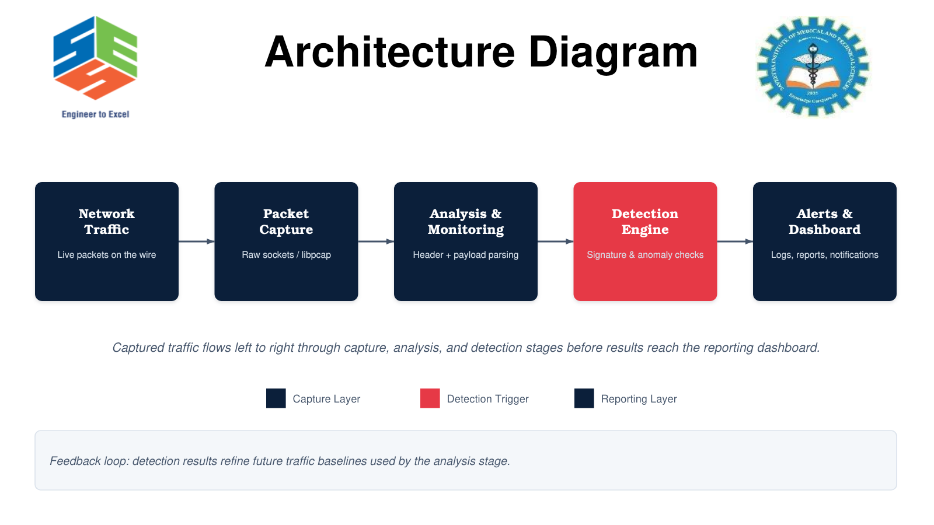
Figure 3.1 End-to-end NIDS architecture

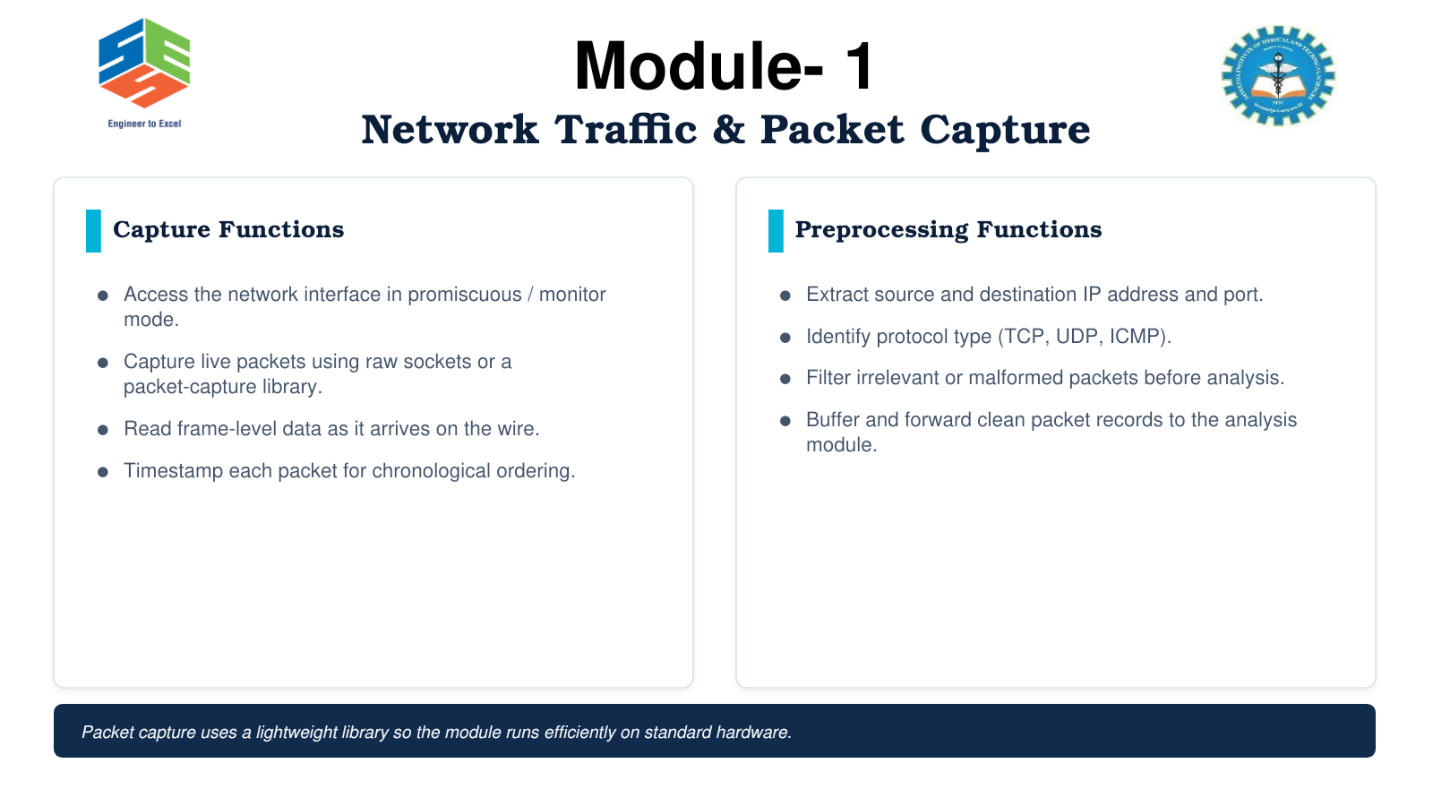
Figure 3.2 Module 1 - network traffic and packet capture
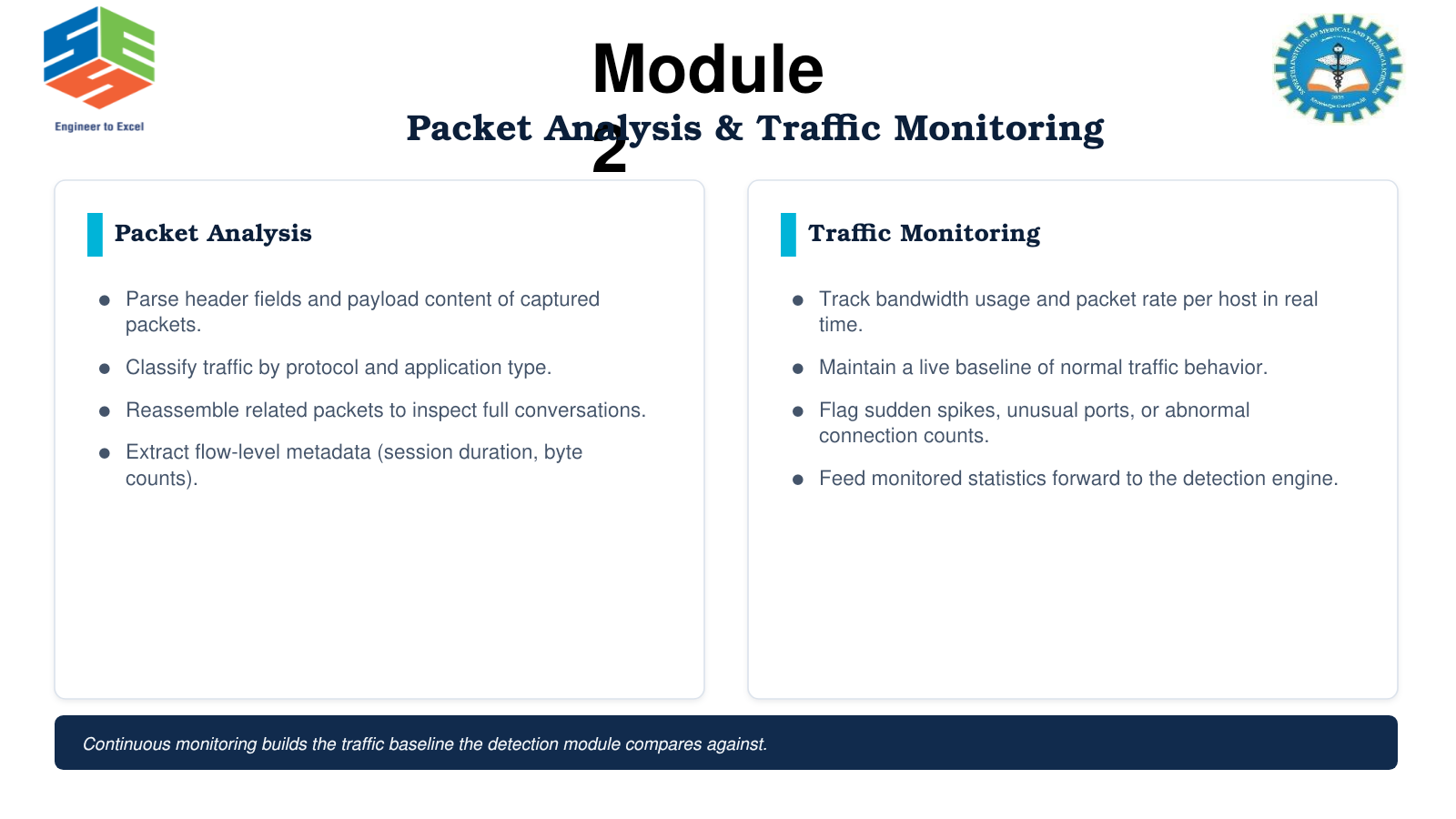
Figure 3.3 Module 2 - packet analysis and traffic monitoring

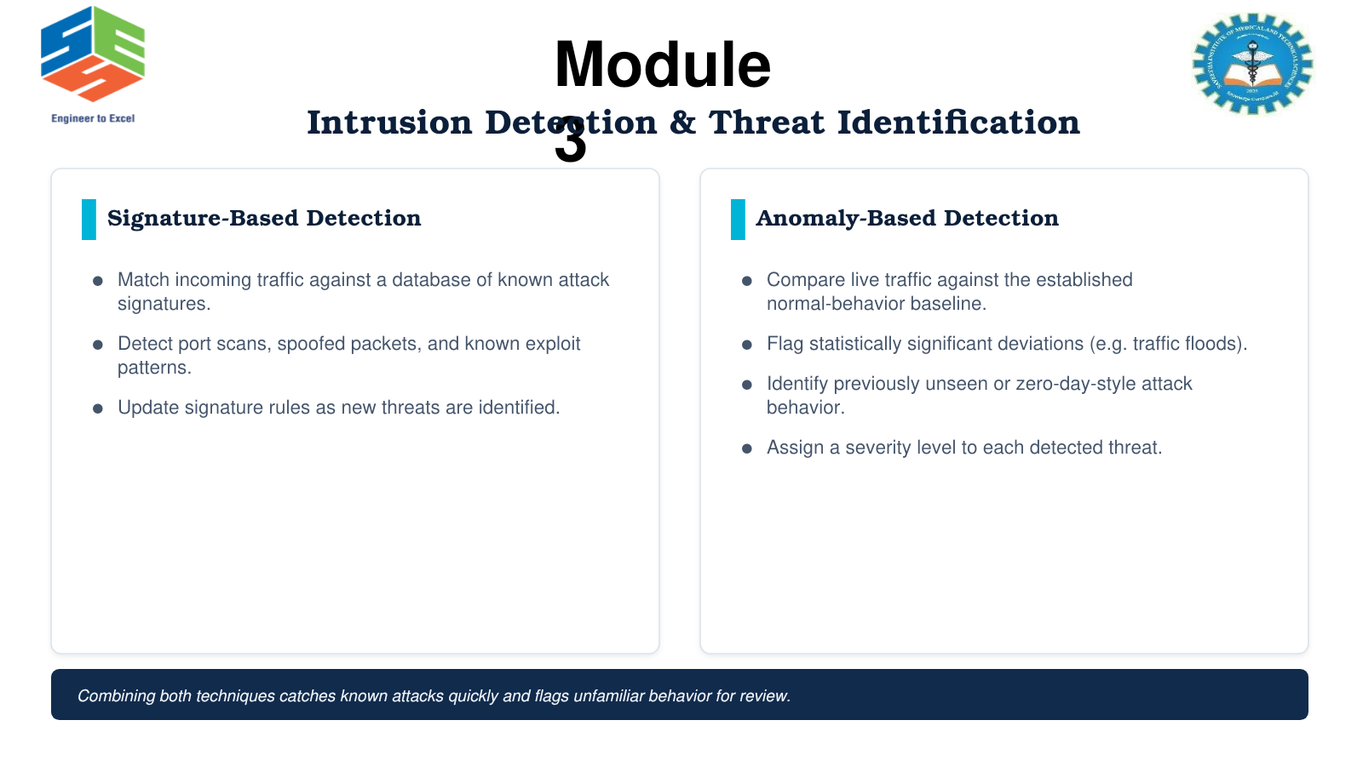
Figure 3.4 Module 3 - intrusion detection and threat identification
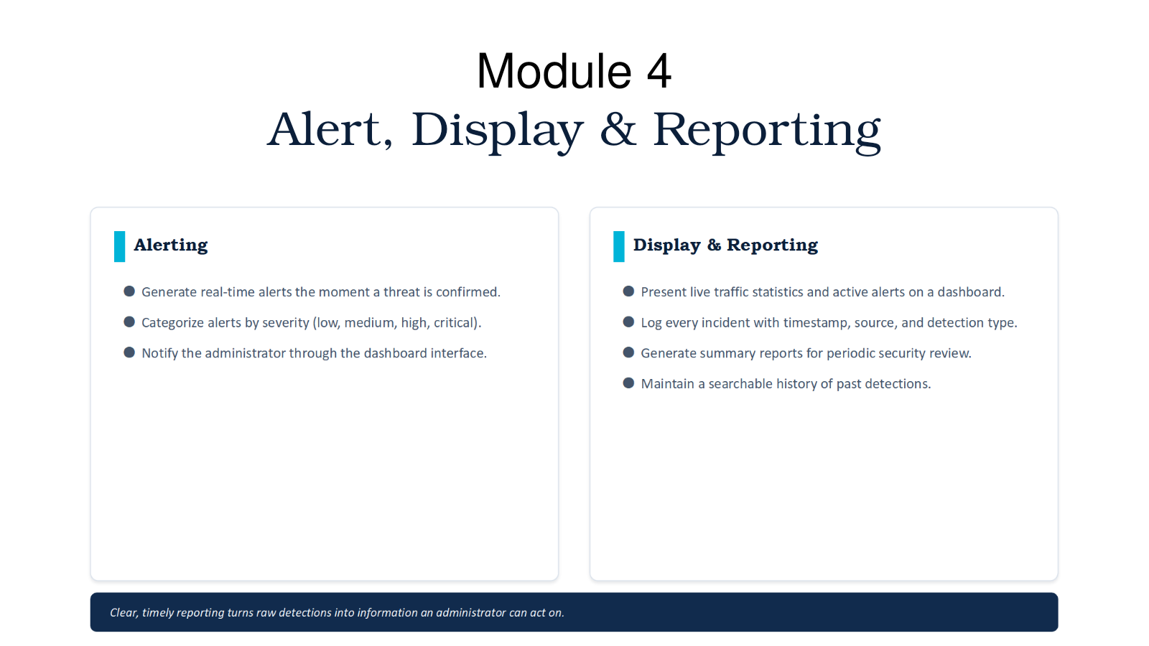
Figure 3.5 Module 4 - alert, display and reporting

3.6 Detection Logic and Data Flow
The capture layer applies an interface and Berkeley Packet Filter where available, timestamps accepted frames, and places bounded records in a queue. The analysis layer validates lengths before parsing, normalizes addresses and protocols, and updates flow state. The detection layer evaluates signature conditions and time-window statistics such as unique destination ports, connection rate, packet rate, malformed headers, and source-address inconsistencies. The reporting layer rate-limits duplicate alerts, assigns severity, writes structured logs, and displays live summaries. Feedback from confirmed alerts can refine allowlists and baselines, but automatic learning must not silently suppress high-risk events.

3.7 Trade-off Analysis
Decision | Alternative | Benefit | Disadvantage | Justification
Hybrid detection | Signature only | Known and unfamiliar patterns | More tuning and false positives | Balances coverage and explainability
Flow metadata first | Store all payloads | Lower storage and privacy exposure | Less content visibility | Appropriate default for academic monitoring
Passive IDS | Inline IPS | No accidental blocking | Cannot stop an attack | Safer first prototype
Local deployment | Cloud-only capture | Simple, low-latency and controlled | Limited multi-site view | Matches small-network scope
Structured logs | Console only | Searchable and integrable | Storage and access control needed | Required for reporting

3.8 Sustainability, Ethics, Safety, Risk & Security
Domain | Evidence / Concern | Impact on Design
Sustainability | Continuous deep inspection consumes compute and storage | Filters, flow aggregation, rotation and retention limits
Ethics and law | Traffic may contain private communications | Written authorization, data minimization and access control
Safety | Aggressive scans/floods can disrupt services | Isolated lab, rate limits and stop procedure
Security | Parser bugs and crafted packets can attack the monitor | Length validation, least privilege and dependency updates
Integrity | False or altered alerts undermine response | Timestamped, append-oriented and protected logs

Risk | Likelihood | Severity | Level | Mitigation | Residual
Unauthorized capture | Low | High | High | Written scope, interface allowlist and audit log | Low
False positive overload | Medium | Medium | Medium | Tuning, suppression window and analyst feedback | Low-Med
Dropped packets | Medium | High | High | Bounded queues, capture counters and performance test | Medium
Malformed-packet crash | Medium | High | High | Length checks, exception isolation and fuzz tests | Low-Med
Sensitive-log exposure | Low-Med | High | High | Minimize payload, encrypt storage and restrict access | Low
Test traffic disruption | Low-Med | High | High | Isolated lab and strict rate caps | Low

CHAPTER 4 - IMPLEMENTATION, TESTING & RESULTS

4.1 Development Approach & Resources
Development followed an incremental defensive workflow. Packet capture and protocol parsing were validated first with ordinary traffic. Flow statistics and bounded time windows were then added. Signature and anomaly rules were tested with controlled, non-destructive scenarios in an isolated or explicitly authorized environment. Finally, alerts, logs, and result summaries were integrated.
Tool / Resource | Purpose
Python or equivalent implementation language | Capture, parsing, detection and reporting logic
Scapy / libpcap / raw sockets | Authorized packet capture and protocol access
VS Code / IDE | Development and debugging
Wireshark | Independent packet inspection and comparison
Local virtual machines / loopback lab | Safe normal and suspicious traffic generation
PCAP files | Repeatable offline regression tests
CSV / JSON log | Structured event storage
Git | Version control and rule history

4.2 Implementation Details
Module 1 opens an authorized capture source, applies a filter where appropriate, timestamps frames, rejects clearly malformed records, and forwards a bounded representation. Module 2 parses supported headers only after validating lengths, groups packets into flows, and updates per-host and per-session counters. Module 3 evaluates rule matches and deviations from rolling baselines. Module 4 deduplicates repeated events, attaches severity and evidence, displays live status, and writes an incident record.
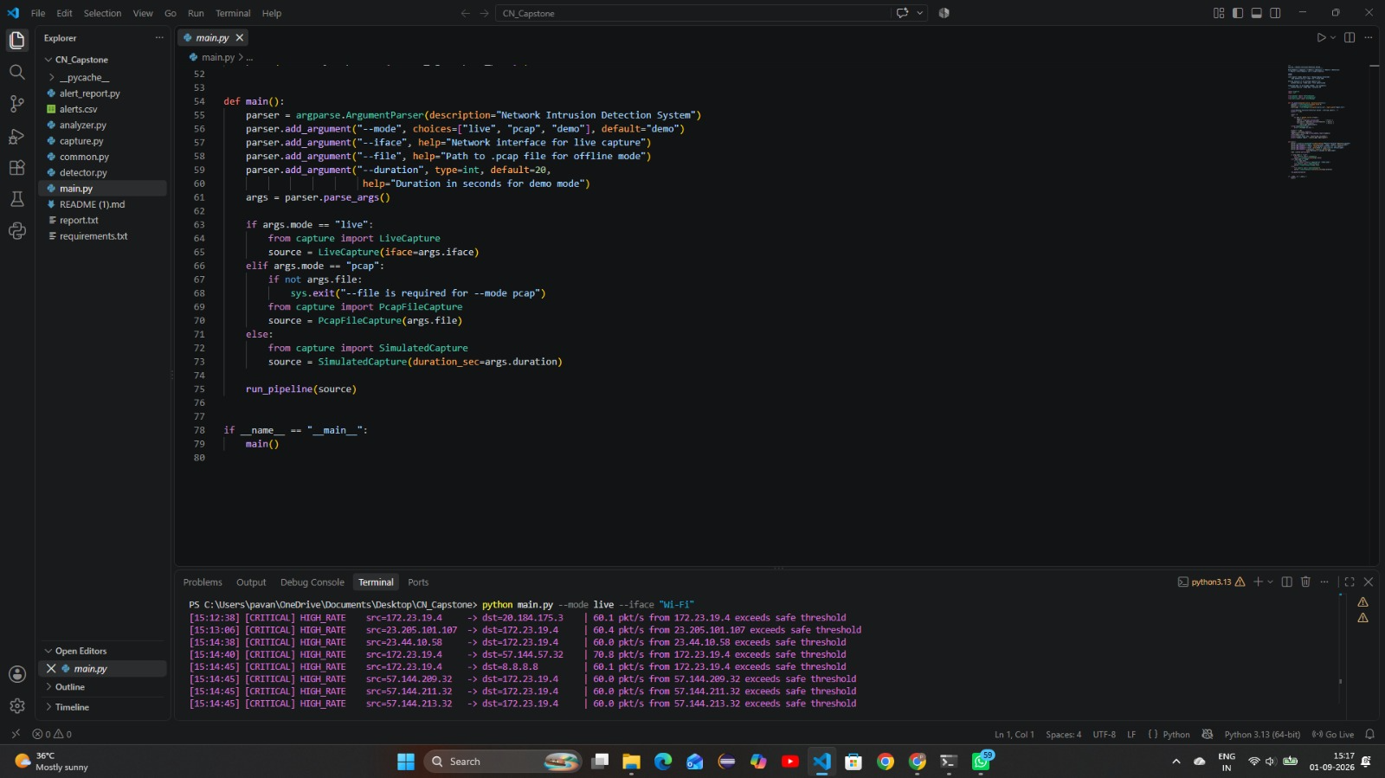
Figure 4.1 Implementation environment and console output from the supplied presentation

4.3 Test Plan & Verification
Requirement | Test Method | Acceptance Criterion | Evidence / Status
Packet capture | Generate authorized ICMP/TCP/UDP traffic | Packets received with timestamps | Console output shown - Pass
Protocol classification | Compare parser output with Wireshark/known PCAP | Supported protocols classified correctly | Reported by presentation - Pass at prototype level
Port-scan detection | Controlled scan against lab host at low rate | Alert identifies source, target and reason | Reported - needs saved test log
Traffic-flood detection | Rate-capped synthetic burst in isolated lab | Rate threshold and severity trigger | Reported - needs measured PPS log
Alert logging | Trigger a known rule | Timestamp, endpoints, type and severity stored | Reporting module defined; screenshot limited
False-positive evaluation | Run labelled normal trace | Confusion matrix and FPR calculated | Not supplied - Not tested
Performance | Replay increasing PCAP rates | Throughput and drop rate recorded | Not supplied - Not tested
Recovery | Interrupt capture or supply malformed PCAP | Process recovers without data corruption | Not supplied - Future test

4.4 Result Summary
Reported Outcome | Interpretation | Evidence Strength
Live packets captured and analyzed | Core pipeline executes on local system | Implementation screenshot and presentation statement
Normal and suspicious patterns classified | Detection logic produces different outcomes | Prototype claim; labelled dataset absent
Port scans and traffic floods detected | Common controlled behaviors trigger rules | Prototype claim; raw alert logs absent
Timely alerts and incident logs generated | Reporting stage is integrated | Module output described; detailed metrics absent
Less manual monitoring required | Automation improves visibility | Qualitative benefit

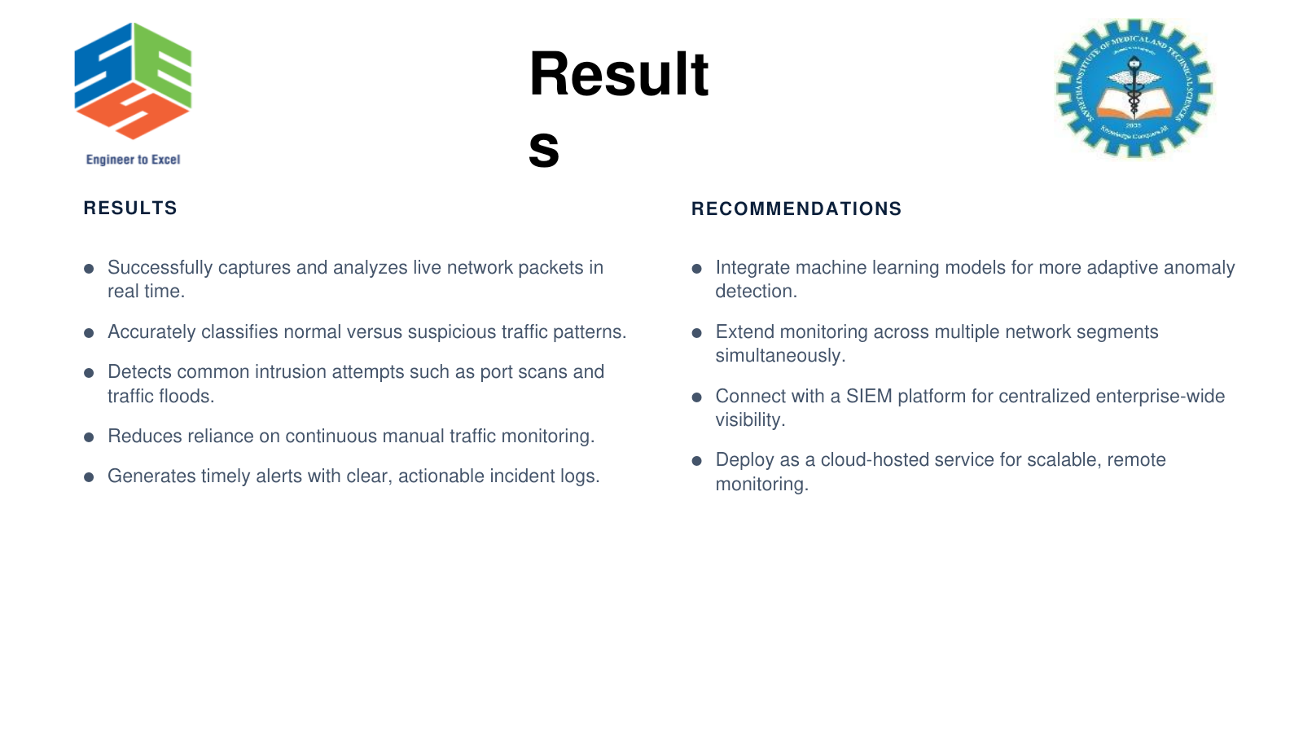
Figure 4.2 Results and recommendations reported in the presentation

4.5 Data Analysis & Engineering Judgment
The available evidence is sufficient to identify a functioning prototype but not to quantify detection accuracy or production readiness. “Accurately classifies” requires labelled ground truth and at least true positives, false positives, true negatives, false negatives, precision, recall, F1 score, and false-positive rate. “Real time” requires packet throughput, processing latency, CPU and memory use, and dropped-packet measurements. The responsible conclusion is therefore that the four-stage pipeline and representative detections were demonstrated, while quantitative performance remains a required validation activity.
Metric | Formula / Measurement
Precision | TP / (TP + FP)
Recall / Detection Rate | TP / (TP + FN)
False Positive Rate | FP / (FP + TN)
F1 Score | 2 × Precision × Recall / (Precision + Recall)
Processing latency | Alert timestamp - final triggering packet timestamp
Packet loss | Capture drop count / packets presented
Throughput | Packets or bits processed per second

4.6 Achievement of Objectives
Objective | Evidence | Achievement
Packet capture | Implementation and console screenshot | Fully at prototype level
Packet and flow analysis | Presentation workflow and output | Fully at prototype level
Hybrid intrusion detection | Signature and anomaly design; reported cases | Partially validated
Alert and reporting | Module design and reported incident logs | Partially validated
Quantitative accuracy | No labelled benchmark supplied | Not yet achieved
Enterprise multi-segment operation | Future recommendation | Not achieved / future

4.7 Strengths & Limitations
Strengths
- Modular capture-analyze-detect-report pipeline.
- Hybrid detection improves coverage beyond static firewall rules.
- Runs locally on standard hardware and supports repeatable PCAP analysis.
- Transparent rule reasons support administrator review.
Limitations
- No supplied labelled dataset, confusion matrix, latency, throughput, or drop-rate results.
- Encrypted traffic restricts payload inspection.
- Anomaly thresholds require environment-specific tuning.
- A passive IDS alerts but does not block malicious traffic.
- Capture and logging create privacy and storage responsibilities.

4.8 Project Planning, Roles & Budget
Week | Milestone
1 | Problem definition, authorization scope and literature review
2 | Capture interface and PCAP handling
3 | Protocol parser and flow statistics
4 | Signature and anomaly rules
5 | Alerts, logging and controlled test cases
6 | Analysis, documentation and presentation

Student | Primary Responsibility | Actual Contribution
P. Hemanth Reddy | Module 1 | Capture layer and validation
U. Pavanesh Reddy | Module 2 | Parsing and live statistics
M. M. Anil | Module 3 | Rules, anomaly checks and threat levels
M. Rahul Reddy | Module 4 | Alerts, logs, display and report assembly

Item | Estimated Cost (INR)
Existing laptop/desktop | Available resource
Open-source software | 0
Router / isolated lab network | 1,000-2,500 if not available
External network adapter | 700-1,500 if required
Storage / backup media | 500-1,000
Approximate additional total | 0-5,000 depending on existing resources

Replace estimates with actual bills or “institutional resource” entries before final submission.

CHAPTER 5 - CONCLUSION, FUTURE WORK AND REFLECTION

5.1 Conclusion
The project presents a lightweight Network Intrusion Detection System organized into four modules: packet capture, packet analysis and monitoring, hybrid intrusion detection, and alert/reporting. The implementation evidence and presentation results support prototype-level packet processing and representative scan/flood detection. The modular design is educational, extensible, and appropriate for an authorized small-network laboratory. However, production claims require labelled accuracy testing, performance measurement, hardened parsing, privacy controls, tuning, and independent security review. The project’s main engineering contribution is the complete and explainable monitoring pipeline rather than a claim of guaranteed detection.

5.2 Future Work
- Build a labelled dataset from authorized normal and attack PCAPs and publish confusion-matrix metrics.
- Benchmark throughput, latency, memory, CPU use, and dropped packets at increasing replay rates.
- Integrate Suricata or Snort as a comparison baseline.
- Add validated machine-learning models with drift monitoring and explainable features.
- Support multi-sensor deployment and SIEM export using structured schemas.
- Use encrypted-traffic metadata rather than attempting unauthorized decryption.
- Harden parsers with fuzzing, sandboxing, least privilege, signed rules, and secure updates.
- Add analyst acknowledgement, case management, retention policy, and role-based access.

5.3 Professional Learning & Individual Reflection
P. Hemanth Reddy: I learned how interface selection, filters, timestamps, and bounded buffers affect whether later analysis is trustworthy. If repeating the work, I would measure capture loss at each offered traffic rate.
U. Pavanesh Reddy: I learned to validate packet lengths before parsing and to convert packet records into flow-level statistics. I would add IPv6 coverage and regression PCAP tests.
M. M. Anil: I learned that signature accuracy and anomaly sensitivity involve different trade-offs. I would calculate a confusion matrix and tune thresholds from labelled validation data.
M. Rahul Reddy: I learned that an alert must contain evidence, severity, and a clear response path. I would improve deduplication, SIEM export, acknowledgement, and retention controls.

REFERENCES
[1] M. Roesch, “Snort: Lightweight intrusion detection for networks,” Proc. 13th USENIX Conf. System Administration, 1999.
[2] NIST, “Guide to Intrusion Detection and Prevention Systems (IDPS),” Special Publication 800-94, 2007.
[3] NIST, “The NIST Cybersecurity Framework (CSF) 2.0,” 2024.
[4] V. Paxson, “Bro: A system for detecting network intruders in real-time,” Computer Networks, vol. 31, no. 23-24, pp. 2435-2463, 1999.
[5] The Zeek Project, “Zeek Network Security Monitor Documentation.”
[6] Open Information Security Foundation, “Suricata User Guide.”
[7] The Tcpdump Group, “libpcap / tcpdump documentation.”
[8] G. Combs et al., “Wireshark User’s Guide.”
[9] IETF, “Internet Protocol,” RFC 791; “Transmission Control Protocol,” RFC 9293; “User Datagram Protocol,” RFC 768; “ICMP,” RFC 792.
[10] OASIS, “STIX Version 2.1” and “TAXII Version 2.1,” OASIS Standards, 2021.
[11] A. Khraisat et al., “Survey of intrusion detection systems: techniques, datasets and challenges,” Cybersecurity, vol. 2, art. 20, 2019.
[12] Project team, “Network Intrusion Detection System Using Packet Analysis and Traffic Monitoring,” capstone presentation and implementation evidence, Sept. 2026.

APPENDICES

Appendix A - Example Defensive Detection Rules
Condition | Defensive Interpretation | Suggested Severity
One source contacts many destination ports within a short authorized test window | Possible horizontal or vertical port scan | Medium
Packet rate greatly exceeds host baseline | Possible traffic flood or misconfiguration | High
Malformed header length or inconsistent flags | Evasion attempt or corrupt traffic | Medium
Known approved signature match | Known suspicious pattern; verify context | Rule-dependent
Repeated failed connections to restricted service | Brute-force or automated probing indicator | Medium-High

Thresholds must be derived from local baseline data and validated. These rules are defensive descriptions, not instructions for attacking a network.

Appendix B - Essential Processing Pseudocode
open only an authorized capture interface
apply an approved capture filter
for each packet:
validate frame and header lengths
timestamp and parse supported protocols
update bounded host and flow statistics
evaluate signature rules
compare rates and features with baseline
if a rule or anomaly threshold is met:
assign severity and evidence
suppress duplicate alerts within policy window
write protected structured log and notify dashboard
record capture drops, processing latency and health counters

Appendix C - Authorization and Privacy Checklist
- Written owner authorization identifies interfaces, hosts, dates, users, and permitted test methods.
- Attack simulations run only in an isolated or explicitly approved environment.
- Payload collection is disabled unless necessary, documented, and authorized.
- Logs are encrypted or access-controlled and retained only for an approved period.
- Credentials, personal data, and sensitive payloads are redacted from reports and screenshots.
- A stop procedure exists if tests affect availability.

Appendix D - Evidence Required for Final Viva
Evidence | Purpose
Dated PCAP and hash | Repeatable input and integrity
Configuration/rule version | Reproducibility
Normal and attack labels | Ground truth
Confusion matrix | Accuracy evaluation
Throughput/latency/drop log | Real-time performance
Alert JSON/CSV samples | Reporting verification
Authorization sheet | Ethical and legal compliance

Appendix E - Capstone Outcome Mapping
Outcome Evidence | Area | Location
Complex engineering problem formulation | SO1 | Chapters 1-2
Engineering design under constraints | SO2 | Chapter 3
Technical communication | SO3 | Whole report and presentation
Ethics and professional responsibility | SO4 | Section 3.8 and Appendix C
Teamwork and leadership | SO5 | Contribution statement and Section 4.8
Experimentation and engineering judgment | SO6 | Sections 4.3-4.6
Independent knowledge acquisition | SO7 | Section 5.3
Standards, risk and security | SO2/SO4 | Sections 3.2 and 3.8

